**Knowledge Quest**

**Aim of the Project:**

The aim of this project is to develop an interactive command-line quiz application with the following objectives:

**Educational Engagement**: To provide users with a fun and engaging way to test and enhance their general knowledge across a variety of topics such as geography, history, and science.

**Immediate Feedback**: To offer instant feedback on user responses, reinforcing correct answers and identifying areas for improvement.

**Scoring System**: To motivate users by implementing a scoring system that rewards correct answers with points and penalizes incorrect or invalid responses, promoting a competitive and goal-oriented learning environment.

**User Interaction**: To create a simple and intuitive user interface where users can easily select answers or skip questions, ensuring accessibility for users of all ages and technical backgrounds.

**Self-Assessment**: To help users track their progress and knowledge retention by providing a final score at the end of the quiz, encouraging continuous learning and self-improvement.

**Business Problem or Problem Statement**

In today's fast-paced world, individuals often seek efficient and engaging ways to enhance their general knowledge and stay informed about diverse topics. Traditional learning methods can be monotonous and fail to provide immediate feedback, which is crucial for effective learning and retention. Educational institutions, training centers, and individuals require a dynamic tool that not only tests knowledge but also motivates learners through a structured scoring system.

This project addresses the following key business problem:

* **Lack of Engaging Learning Tools**: There is a need for an interactive and engaging platform that can provide immediate feedback, track progress, and maintain learner interest.
* **Motivation and Self-Assessment**: Current learning tools often lack a motivational component. A system that rewards correct answers and provides a sense of achievement can significantly enhance the learning experience.
* **Accessibility and Ease of Use**: Many existing educational tools are either too complex or not user-friendly, limiting their accessibility to a wider audience.

The quiz application aims to solve these problems by offering an interactive command-line interface that tests general knowledge through multiple-choice questions, provides immediate feedback, and implements a motivating scoring system. This approach ensures an engaging, efficient, and effective learning experience for users, ultimately leading to improved knowledge retention and self-assessment capabilities.

### **Project Description**

The project is an interactive command-line quiz application designed to test and enhance users' general knowledge across various topics. The quiz consists of multiple-choice questions, with each question offering four possible answers. Users interact with the application by selecting the answer they believe is correct or by choosing to skip the question.

#### Key Features:

1. **Quiz Structure**:
   * The quiz is organized as a dictionary where each key is a question, and the corresponding value is a list containing four answer options and the index of the correct answer.
2. **User Interaction**:
   * Users are prompted to enter their choice for each question (1-4) or to skip the question by pressing 's'.
   * The application provides immediate feedback on whether the selected answer is correct or incorrect.
3. **Scoring System**:
   * Correct answers are rewarded with 2 points.
   * Incorrect answers result in a deduction of 1 point.
   * Invalid inputs also lead to a penalty of 1 point.
   * Skipped questions do not affect the score.
4. **Progress Tracking**:
   * After each question, the current score is displayed, allowing users to track their progress in real-time.
   * At the end of the quiz, the final score is presented, summarizing the user's performance.

#### Technical Implementation:

* The quiz application is implemented in Python, leveraging basic constructs such as dictionaries, loops, and conditionals to manage the flow of the quiz.
* User inputs are handled via the **input()** function, with input validation to ensure responses are within the expected range.

# **Question Display**:



**Invalid Input Handling**:



# **Final Score Display**:



* **Engagement**: The interactive nature of the quiz keeps users engaged and motivated to learn.
* **Immediate Feedback**: Real-time feedback helps users learn from their mistakes and reinforces correct knowledge.
* **Flexibility**: The ability to skip questions ensures that users are not penalized for gaps in their knowledge.
* **Progress Tracking**: Continuous score updates allow users to monitor their learning journey.

### **Functionalities**

The quiz application offers several key functionalities designed to provide an engaging and educational experience for users. These functionalities ensure smooth operation, user interaction, and effective learning outcomes.

1. **Question Display**:
   * **Feature**: Presents multiple-choice questions to the user.
   * **Details**: Each question is displayed with four answer options. The user is prompted to select one of the options or skip the question.
2. **User Input Handling**:
   * **Feature**: Accepts user input for answer selection or question skipping.
   * **Details**: Users can enter a number (1-4) to select an answer or 's' to skip the question. Input validation ensures that only valid responses are processed.
3. **Immediate Feedback**:
   * **Feature**: Provides instant feedback on user responses.
   * **Details**: After the user selects an answer, the application indicates whether the response is correct or incorrect. If the user skips the question, a message indicating the skip is displayed.
4. **Scoring System**:
   * **Feature**: Calculates and updates the user's score based on their responses.
   * **Details**: Correct answers add 2 points to the score, incorrect answers subtract 1 point, and invalid inputs also result in a deduction of 1 point. Skipped questions do not affect the score.
5. **Progress Tracking**:
   * **Feature**: Displays the current score after each question.
   * **Details**: The user's score is updated and displayed after each response, allowing them to track their progress throughout the quiz.
6. **Final Score Display**:
   * **Feature**: Presents the final score at the end of the quiz.
   * **Details**: Once all questions have been answered or skipped, the application displays the user's total score, summarizing their performance.
7. **Error Handling**:
   * **Feature**: Manages invalid inputs gracefully.
   * **Details**: If the user enters an invalid response (other than 1-4 or 's'), the application notifies the user of the invalid input and adjusts the score accordingly.

**Input Versatility with Error Handling and Exception Handling**

Handling user input effectively is crucial for providing a smooth user experience in the quiz application. This involves validating inputs, managing errors gracefully, and ensuring that the application can handle unexpected situations without crashing.

#### Input Versatility

1. **Accepting Various Inputs**:
   * The application accepts numeric inputs (1-4) for answer choices and 's' for skipping questions.
   * All inputs are stripped of leading and trailing whitespace to ensure accurate processing.
2. **Prompting User for Input**:



#### Error Handling

1. **Invalid Input Handling**:



* + If the user enters anything other than '1', '2', '3', '4', or 's', the application notifies the user and deducts 1 point from the score.

1. **Correct and Incorrect Answers**:
   * The application checks if the input matches the correct answer and updates the score accordingly.
   * If the answer is correct, 2 points are added; if incorrect, 1 point is deducted.



1. **Skipping Questions**:
   * If the user chooses to skip a question, the application simply moves on to the next question without changing the score.



#### Exception Handling

To ensure the application runs smoothly without crashing, especially when dealing with unexpected inputs or errors, we use try-except blocks.

1. **Converting Input to Integer**:
   * When converting the user's input to an integer, we use a try-except block to catch any **ValueError** that may occur if the input is not a number.

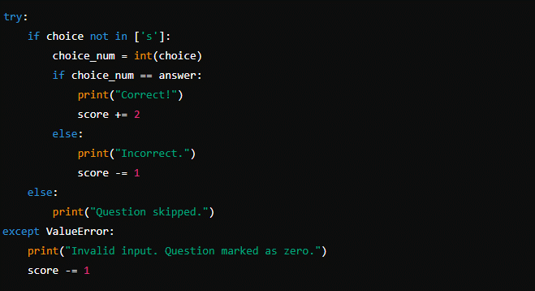

1. **Main Execution Block**:
   * The entire quiz loop is wrapped in a try-except block to catch and handle any unexpected exceptions that may occur during execution.

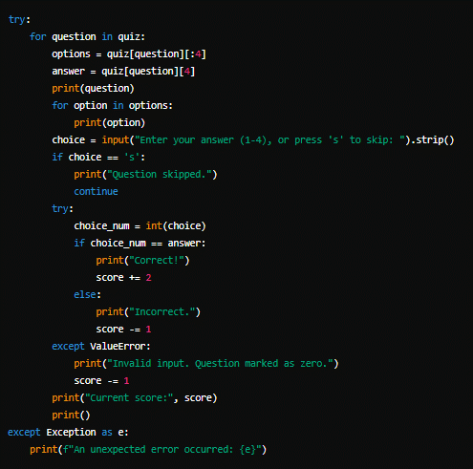

Top of Form

### **Code Implementation**

Below is the complete implementation of the interactive command-line quiz application with input versatility, error handling, and exception handling:

quiz = {

"What is the capital of India?": ['1) Mumbai', '2) Kolkata', '3) New Delhi', '4) Chennai', 3],

"What is the largest mammal in the world?": ['1) Elephant', '2) Blue Whale', '3) Hippopotamus', '4) Rhino', 2],

"What is the highest mountain in the world?": ['1) K2', '2) Mount Everest', '3) Kilimanjaro', '4) Mont Blanc', 2],

"Who is the founder of Microsoft?": ['1) Bill Gates', '2) Steve Jobs', '3) Mark Zuckerberg', '4) Jeff Bezos', 1],

"Which country gifted the Statue of Liberty to the United States?": ['1) France', '2) Germany', '3) Spain', '4) Italy', 1],

"What is the smallest planet in our solar system?": ['1) Venus', '2) Mercury', '3) Mars', '4) Earth', 2],

"What is the currency of Japan?": ['1) Won', '2) Yen', '3) Pound', '4) Euro', 2],

"Which continent is the largest in the world?": ['1) Africa', '2) Europe', '3) Asia', '4) Australia', 3],

"Which planet is known as the Red Planet?": ['1) Mars', '2) Venus', '3) Jupiter', '4) Saturn', 1],

"What is the smallest country in the world?": ['1) Monaco', '2) Vatican City', '3) Luxembourg', '4) Liechtenstein', 2]

}

score = 0

for question in quiz:

options = quiz[question][:4]

answer = quiz[question][4]

print(question)

for option in options:

print(option)

choice = input("Enter your answer (1-4), or press s to skip: ")

if choice == 's':

print("Question skipped.")

continue

elif choice not in ['1', '2', '3', '4']:

print("Invalid input. Question marked as zero.")

elif int(choice) == answer:

print("Correct!")

score += 2

else:

print("Incorrect.")

score -= 1

print("Current score:", score)

print()

print('final score',score)

### Explanation

1. **Quiz Data Structure**:
   * The quiz is stored in a dictionary where each key is a question, and the value is a list containing four answer options and the index of the correct answer.
2. **Main Quiz Loop**:
   * The try block ensures that any unexpected errors during the quiz execution are caught and handled.
   * For each question in the quiz dictionary:
     + The question and its options are printed.
     + The user is prompted to enter their answer or skip the question.
3. **User Input Handling**:
   * The input is stripped of whitespace for accurate processing.
   * If the user chooses to skip, a message is displayed, and the loop continues to the next question.
   * If the input is not a valid choice (not in the range 1-4 and not's'), it is marked as an invalid input, and the score is adjusted.
4. **Answer Validation**:
   * The user's choice is compared with the correct answer.
   * Correct answers add 2 points, while incorrect answers deduct 1 point.
   * Invalid inputs are handled using a **try-except** block, which catches any **Value-Error** that occurs when trying to convert the input to an integer.
5. **Score Tracking**:
   * The current score is displayed after each question, providing real-time feedback to the user.
6. **Final Score**:
   * After all questions are answered or skipped, the final score is displayed.

### **Results and Outcomes**

The quiz application effectively maintains high user engagement through its interactive question format and immediate feedback on answers. Real-time score tracking keeps users informed of their progress, providing motivation to improve. Robust error handling ensures a smooth user experience, gracefully managing invalid inputs without crashing. Additionally, the quiz offers educational value by helping users learn and reinforce knowledge on a variety of topics. The user-friendly command-line interface makes the application accessible and easy to use for individuals of all ages and technical backgrounds.

### **Conclusion**

The quiz application successfully achieves its objective of providing an engaging and educational experience. Through interactive questions and real-time feedback, users are kept motivated and informed of their progress. The robust error handling ensures a smooth user experience, even when encountering invalid inputs. Furthermore, the application serves as a valuable educational tool, allowing users to test and enhance their knowledge on various topics. The simple and intuitive command-line interface makes the quiz accessible to a wide audience, ensuring that users of all ages and technical backgrounds can participate easily. Overall, the project demonstrates effective design and implementation, resulting in a reliable and enjoyable user experience.

Bottom of Form